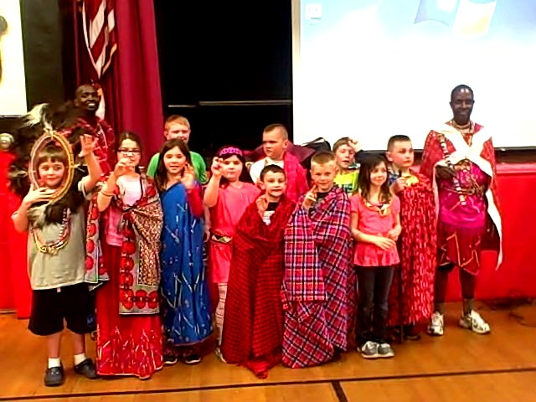

Note to Educators:

- Our presentations include most of the items below, but they are always age appropriate and customized to group requests and interests. References are readily available from schools, libraries, museums and civic organizations.

- Private parties are also held in volunteers’ homes to further get to know our Maasai friends, introduce them to our communities and purchase native jewelry and artifacts.

- Chief Joseph and his group are exciting teachers with excellent English! Ideas:

Elementary: interactive songs and dances. We dress the children in native clothing. Talk about schooling, daily routines and attitude toward school, play, chores and respect in families.

Middle School: above, plus Jumping demonstrations- Maasai wrestling. Cultural traditions, meaning of dress and colors, jewelry making, social structure. Learn to count to 10 in Swahili!

High School/College: history and politics of the Maasai. Anthropology in Maasailand. Cultural traditions and current challenges in assimilating into modern times. Education in Maasailand. Social attitudes. Ways to assist with supply of clean water, medical improvements and education. Opportunities to volunteer and/or visit our Kenyan guest house.

Chief Joseph has visited Music, Art, and PE classes to demonstrate the Maasai version
of those classes in Maasailand!
(Jumping, dancing, singing, crafts)

Also, please share with your colleagues for their consideration and also with anyone you think may have an interest in hosting Chief Joseph at their school or public venue. The experience is amazing, and all money raised goes directly to health, education and welfare within the Maasai community. Thank you!

Virginia B. Armstrong NY Rep
info@leavingfootprints.org
631-835-1520

